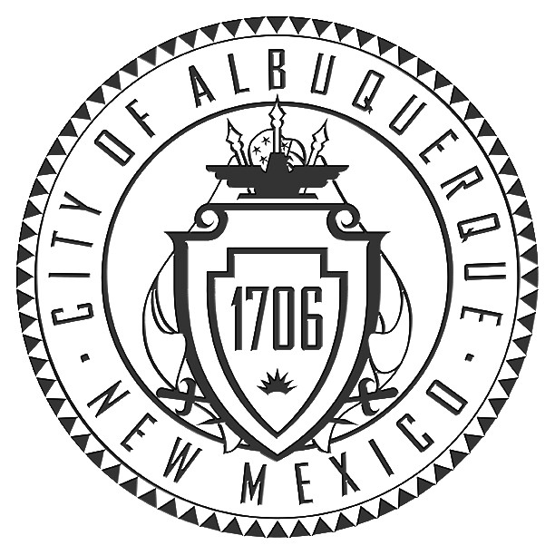
Office of the City Clerk

P.O. Box 1293
Albuquerque, NM 87103
Phone (505) 768-3030 Fax (505) 768-2845
www.cabq.gov/clerk

Amy B. Bailey, City Clerk

State of New Mexico )
) s.s.
County of Bernalillo )

DECLARATION OF INTENT TO SEEK PUBLIC FINANCING PURSUANT TO THE OPEN AND ETHICAL ELECTIONS CODE

The Applicant Candidate named below herewith swears or affirms that they have chosen to obtain campaign financing pursuant to the Open and Ethical Elections Code for the elected City of Albuquerque office designated below; that they have complied with and will continue to comply with the Open and Ethical Election Code contribution and expenditure limits and all other requirements set forth in the Open and Ethical Elections Code. The Applicant Candidate agrees that any money received from the Fund shall not be used to retire a prior campaign debt from a previous election period.

The Applicant Candidate further agrees to comply with the Regulations of the Albuquerque City Clerk for the Open and Ethical Elections Code, including but not limited to all campaign contribution and expenditure reporting requirements specified therein.

The Applicant Candidate understands that five-dollar ($5.00) Qualifying Contributions may not be obtained prior to May 1, 2011 or after May 31, 2011 and that all Qualifying Contributions must be obtained only with accompanying City Clerk receipt forms.

The Applicant Candidate is a candidate for the Office of City Councilor, District ___________.

________________________________
Applicant Candidate (Signature)

________________________________
Print or type name of Applicant Candidate

Sworn or affirmed before me, the undersigned authority by _______________________ this ________day of____________2011.

________________________________
Notary Public

My Commission Expires _____________________

